**1**

**Transforming Tasks: Workshop 4**

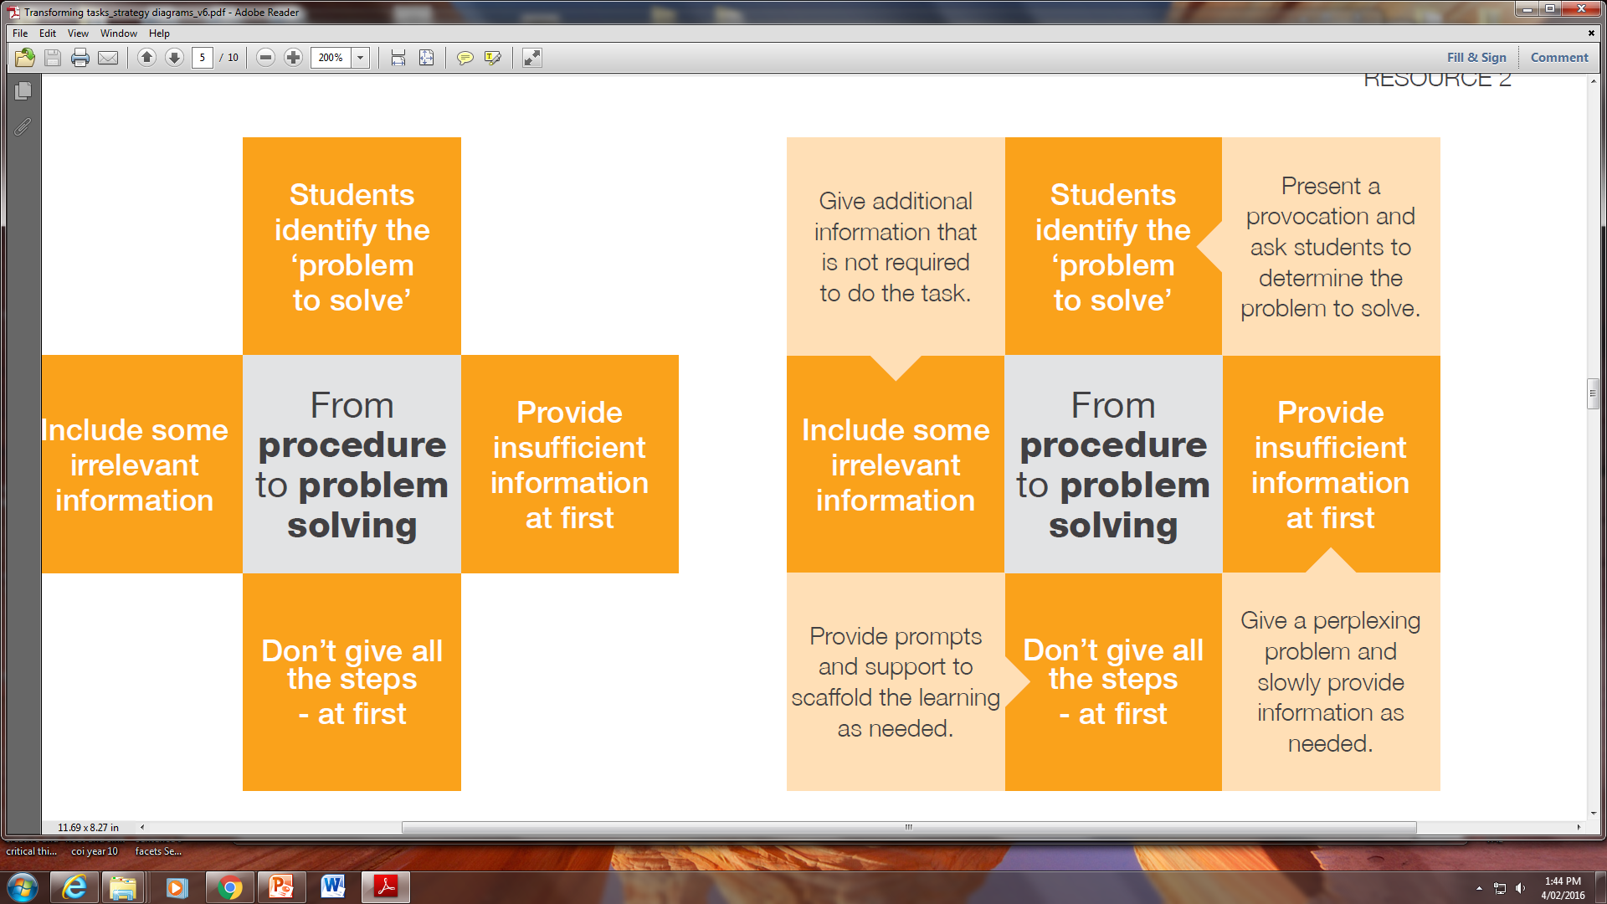

**Procedure to problem solving**

**Strategy and example techniques**

**Teaching for Effective Learning**

**Domain 2**

**3**

**Transforming Tasks: Workshop 4**

